CONDUCTING INTERNAL INVESTIGATIONS
NEW COURSE MARKETING MATERIAL

Conducting Internal Investigations
Spencer’s eGuides cover various topics that focus on business risk and how it may be tackled. The material is a mix of slide presentations, models, fact sheets, case studies, short exercises and checklists. The PDF format means this is a readily accessible staff training resource, aimed at everyone who works for, or is associated with an organization where business risk needs to be properly understood and managed. The material is relevant to all business sectors; public, private and not-for-profit organizations - globally. There are currently four eGuides available covering:
- Governance, Risk and Business Controls Assurance.
- Conducting Internal Investigations.
- Business Fraud Risk Management.
- Introduction to Internal Auditing.

We deal here with Conducting Internal Investigations, which is a key skill that should be promoted in all organizations. It is essential that you know how to conduct a professional investigation if you are ever asked to be lead on, or be associated with this task.
Good managers are proud to say, they have a method in place to make sure minor problems are investigated and addressed before they have a chance to accelerate and grow into major problems. The worst thing an organization can do is know there is a problem, but fail to quickly sort it out or try to cover it up.
Your eGuide represents a stand-alone course that is aimed at everyone who needs to know a bit more about this topic. The introductory material will also be useful for business students and has one simple aim:
To present a brief introduction to internal investigations that will give you an initial understanding of how investigations may be conducted to ensure they are both professional and reliable.
See below for further information.

Sold by Business Controls Training.
Categories - Workplace Performance, Business Administration, Information Security & Fraud, Security & Investigation, Leadership & Management, Risk Assessment, Business Analysis & Process Improvement.
Tags: Internal Investigations, Disciplinary Procedures, Interviewing, Corporate Governance, Risk Management, Internal Control, Compliance.
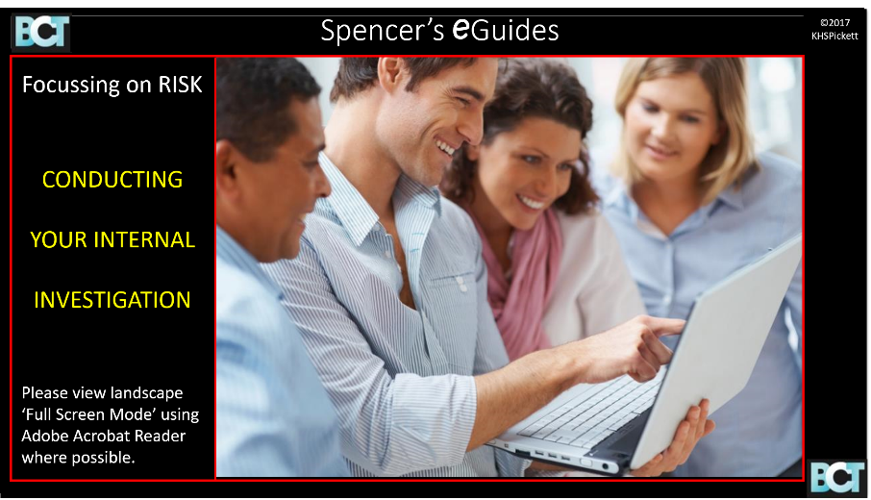
----------------------
FURTHER INFORMATION
All organizations are faced with the prospect of dealing with complaints, allegations of misconduct, near misses, unfortunate incidents and non-routine problems that may arise from time to time in the workplace.
One response is to commission an internal investigation, which is often best carried out by employees as part of their managerial responsibilities. It is essential that all investigations are performed properly so that the initial problem does not make your organization appear dishonest, uncaring or incompetent.
Your investigation could have a profound effect on someone's future prospects and it is essential that you stick to the disciplinary procedure when dealing with misconduct. Moreover, such investigations must be carried out in a fair and balanced manner and in line with best practice.

Good managers are proud to say, they have a method in place to make sure minor problems are investigated and addressed before they have a chance to accelerate and grow into major problems. The worst thing an organization can do is know there is a problem, but fail to quickly sort it out or try to cover it up.

Your eGuide represents a stand-alone course aimed at managers, supervisors, team leaders, and the entire workforce in all organizations from all sectors, globally. Your eGuide is split into two parts. For those who just want an introductory briefing, Part One will take you swiftly through the specially prepared Template, after which you can simply stop.
Part Two provides a formal introduction to the topic based around each part of your Template. There are also a few ‘Read On If You Want More Details’ pages, which you can explore or just skim through. We have one simple aim for this Training Tutorial:
To present a brief introduction to internal investigations that will give you an initial understanding of how investigations may be conducted to ensure they are both professional and reliable.

This
eGuide will be useful for:
- Managers and supervisors.
- Support teams.
- All frontline employees.
- Anyone who may need to lead or be involved in an internal investigation at their workplace.
It applies to all business sectors; public, private and not-for-profit organizations - globally.
Your Part Two Tutorial covers the following:
1. Corporate Accountability.
2. Defining the Problem.
3. Planning and Sign off.
4. Fieldwork and Evidence.
5. Interviewing.
6. Reporting the Results.
7. Risk Culture and Controls.
8. Decisions on Conduct.

It should take around an hour or so to complete the course depending on how many extra notes you wish to study. Some of the Key Features of your eGuide are noted:
- Case studies and worked examples.
- Many short exercises.
- Specially designed models and checklists.
- A range of further information pages that you may explore.
- Several practical examples.
- Notes on various aspects of internal investigations.
- Guidance on conducting an investigation using a simple illustration.
- Convenient and easy to access PDF format.

Your eGuide has been prepared by an experienced training consultant, who has written several books on this, and related topics.
The cost of an individual user download of the PDF is £20 plus VAT. Where the eGuide is being ordered for more than one user, there are discounts available as follows:
Discounts:
10 or more users 10%
20 or more users 15%
30 to 50 users 20%
For larger orders please contact:
enquiries@elearningmarketplace.co.uk

ADDITIONAL INFORMATION
Mobile-compatible Yes
Level Professional Development
Resource-type E-Book
Guided-learning-hours 1 – 2 hours
Subject Internal Investigations
Available for immediate use Yes

ADDITIONAL SCREENSHOTS
